Data Flow Diagram (Description)
You don’t need complex IBM-level DFD. For your project, use this:
Level 0 DFD (Context Level)
User → Service Catalog Form → ServiceNow Database
Flow Explanation:
- User opens Service Catalog.
- User selects Laptop Request item.
- User fills required details.
- UI Policy dynamically shows accessories field.
- User submits request.
- Data stored in ServiceNow catalog tables.

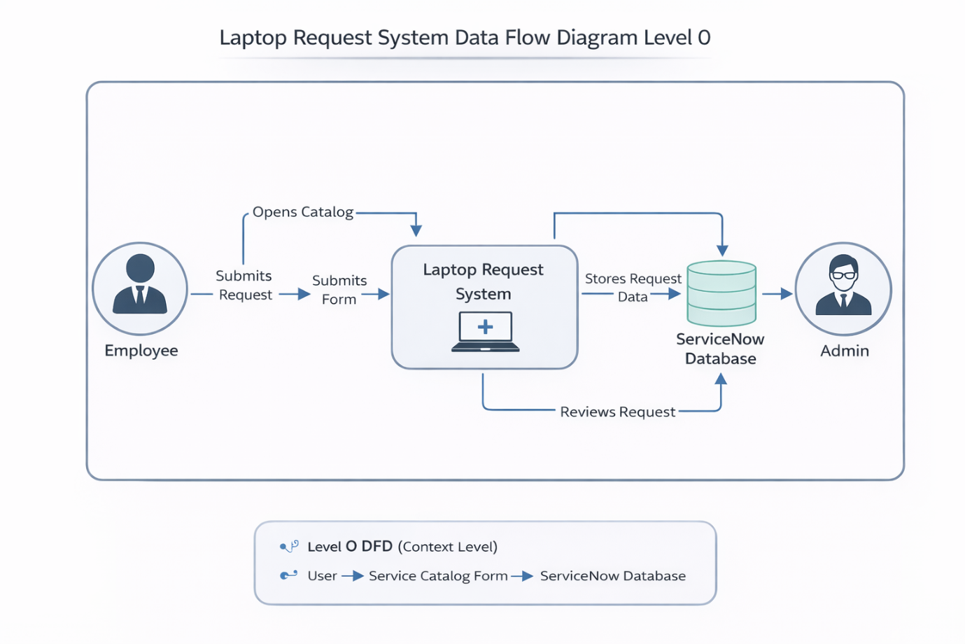

User Stories
User Story No | User Story | Acceptance Criteria
US-1 | As a user, I want to request a laptop | I can open laptop request form
US-2 | As a user, I want to select laptop model | Model dropdown should be available
US-3 | As a user, I want to add accessories | Checkbox should allow selection
US-4 | As a user, I want accessories details field to appear | Field appears when checkbox selected
US-5 | As a user, I want form validation | Form should not submit without required fields
US-6 | As a user, I want reset option | Reset button clears form

